Q1 UDP client
#!/usr/bin/env python3
import socket

sock = socket.socket(socket.AF_INET, socket.SOCK_DGRAM)
udp_host = socket.gethostname()
udp_port = 12345

msg = "My UDP Client message !!"
print("UDP target IP:", udp_host)
print("UDP target Port:", udp_port)

sock.sendto(msg.encode(), (udp_host, udp_port))

data, addr = sock.recvfrom(1024)
print("Server Sent: ", data.decode())

Q1 UDP Time Server
#!/usr/bin/env python3
import socket
import time

sock = socket.socket(socket.AF_INET, socket.SOCK_DGRAM)
udp_host = socket.gethostname()
# udp_host = "172.16.58.56"
udp_port = 12345

sock.bind((udp_host, udp_port))

while True:
print("Waiting for client")
data, address = sock.recvfrom(1024)
currentTime = time.ctime(time.time())
print("Received Messages: ", data.decode(), "from", address)
sock.sendto(currentTime.encode(), address)

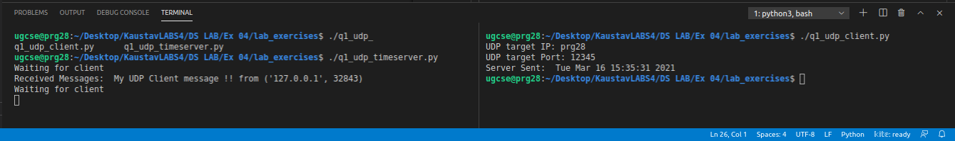
Q2 UDP Chat Server
#!/usr/bin/env python3
import socket
import time

sock = socket.socket(socket.AF_INET, socket.SOCK_DGRAM)
udp_host = socket.gethostname()
udp_port = 12345

sock.bind((udp_host, udp_port))

while True:
print("Waiting for client")
data, address = sock.recvfrom(1024)

print("Received Messages: ", data.decode(), "from", address)
msg = str(input("Enter message to send to client: "))
sock.sendto(msg.encode(), address)

Q2 UDP Client
#!/usr/bin/env python3
import socket

sock = socket.socket(socket.AF_INET, socket.SOCK_DGRAM)
udp_host = socket.gethostname()
udp_port = 12345

# msg = "My First UDP Client message !!"
print("UDP target IP:", udp_host)
print("UDP target Port:", udp_port)

while True:
msg = str(input("Enter message to send to server: "))
sock.sendto(msg.encode(), (udp_host, udp_port))

data,addr = sock.recvfrom(1024)
print("Received Messages: ", data.decode())

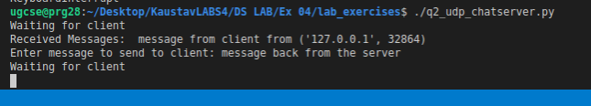
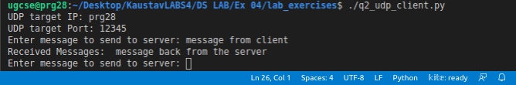
Q3 Client
#!/usr/bin/env python3
import socket
HOST = '172.16.58.136'
PORT = 31624
s = socket.socket()
name = input(str("\nEnter your name: "))
print("\nTrying to connect to ", HOST, "(", PORT, ")\n")
s.connect((HOST, PORT))
print("Connected...\n")
s.send(name.encode())
s_name = s.recv(1024)
s_name = s_name.decode()
print(s_name, "has joined the chat room\nEnter [e] to exit chat room\n")
while True:
message = s.recv(1024)
message = message.decode()
print(s_name, ":", message)
message = input(str("Me : "))
if message == "[e]":
message = "Left chat room!"
s.send(message.encode())
print("\n")
break
s.send(message.encode())
Q3 Server
#!/usr/bin/env python3
import socket
HOST = '127.0.0.1'
PORT = 31621
s = socket.socket()
s.bind((HOST, PORT))
s.listen()
print("\nWaiting for incoming connections...\n")
conn, addr = s.accept()
print("Received connection from ", addr[0], "(", addr[1], ")\n")
s_name = conn.recv(1024)
s_name = s_name.decode()
print(s_name, "has connected to the chat room\nEnter [e] to exit chat room\n")
name = input(str("Enter your name: "))
conn.send(name.encode())
while True:
message = input(str("Me : "))
if message == "[e]":
message = "Left chat room!"
conn.send(message.encode())
print("\n")
break
conn.send(message.encode())
message = conn.recv(1024)
message = message.decode()
print(s_name, ":", message)
